Multiple choice section

|  |  |  |  |  |  |  |  |
| --- | --- | --- | --- | --- | --- | --- | --- |
| Question | 1 | 2 | 3 | 4 | 5 | 6 | 7 |
| Answer | C | D | B | B | D | A | B |

Question 1 [9.1]

**C**

True. Congruent shapes must be identical in shape and size.

Question 2 [9.1]

**D**

SAS. Corresponding two sides are in the same ratio and the included angles are the same value.

Question 3 [9.2]

**B**



Question 4 [9.3]

**A**

Sides need to be in the same ratio, not equal.

Question 5 [9.3]

**D**

Vertically opposite angles are equal. Then the triangles can be proven to be congruent using the SAS test.

Question 6 [9.4]

**A**

These are not the corresponding angles in the triangle.

Question 7 [9.2]

**B**

You can use any test on right-angled triangles (depending on the information given).

Question 8 [9.6] [10A]

B

 = 114°

 = 57°

Multiple-choice total marks: 8

Short answer section

Question 9 2 marks [9.1, 9.2]

(a) An included angle sits between two sides of a triangle.

(b) If two shapes are identical in shape and size, they are said to be congruent.

Question 10 2 marks [9.2]

Similar shapes are identical in shape but different in size. The sizes of the angles are the same but the shape has been either enlarged or reduced. This enlargement/reduction is known as dilation and you measure this by calculating the ratio of the side. For example:

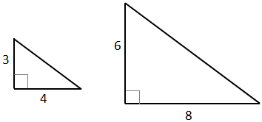

Question 11 4 marks [9.4]

(a) Side ratio  
=   
= 5

(b) x = 5 × 1  
= 5

Question 12 2 marks [9.2]

If all corresponding angles are equal, the two triangles are similar but corresponding sides need to be equal to ensure congruency. For example, the following shapes have corresponding equal angles, but the side lengths are different. They are similar but not congruent shapes.



Question 13 5 marks [9.2]

(a)

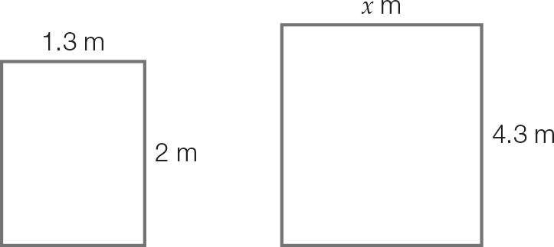

(b) Side ratio   


(c) Dilation factor =   
= ~3.757  
New width =   
= 16.154 m

Question 14 3 marks [9.2]

(a) AB = AC and BD = CD and AD is a shared side.

This satisfies the condition SAS, SSS, AAA and RHS for congruent triangles.

(b) Yes, all the tests can be used.

Question 15 3 marks [9.1]

Medium triangles e.g. ACH  
Small triangles e.g. ABI   
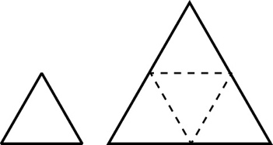

Question 16 3 marks [9.2]

(a) Any three of the following:  
****, ****, ****, ****, ****, ****, 

(b) BCDJ, JDEF, HJFG

(c) There are six pairs:  
∠BIA and ∠DIJ, ∠BID and ∠AIJ, ∠IJD and ∠HJK  
∠IJH and ∠DJK, ∠JKE and ∠HKF, ∠JKH and ∠EKF

Question 17 3 marks [9.3]

AC is a common side.

AB = AD as ABCD is a square.

BC = DC as ABCD is a square.

∠ADC = ∠ABC = 90°

 by SSS and RHS.

Question 18 4 marks [9.2]

(a)   
  
x = 2.33 m

(b) Distance of the tree from the wall  
= 2.33 – 0.6  
= 1.73 m

Short answer total: 30

Extended answer section

Question 19 3 marks [9.3]

** (base angles of isosceles triangle)

AE = CD (given)

AB = CB (given)

 (SAS)

Question 20 6 marks [9.4]

(a) Corresponding angles on parallel lines are equal so the triangles are similar using the AAA test.

(b)    
x = 30

(c)    
y = 12.5

Question 21 6 marks [9.4]

(a) For :  
 = 90° (given)  
EC = AC (given)  
BC = DC (given)  
 (RHS)

(b) For :  
BF = DF (given)  
 (vertically opposite angles)  
 (given)  
 (AAS)

(c) For :   
BF = DF (given)  
 (given)  
CF is common.  
 (RHS)  
 (corresponding angles of congruent triangles)  
CG bisects .

Question 22 4 marks [9.6] [10A]

(a)    
(angle subtended by arc at centre = 2 × angle subtended by arc at circumference)

 (vertically opposite angles)



(b)    
(angle subtended by arc at centre = 2 × angle subtended by arc at circumference)

2

 (straight angle)



Extended answer total: 19

TOTAL test results: 57